Conscious Grit:
from stuck to unstoppable©
Personal Project Twelve
Who do you need on your dancefloor? 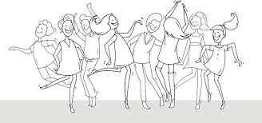
Make two lists:
Your natural partners (refer to the Changemaker Framework. – who did you put in your kitchen cabinet?) | Write down the skills and capabilities that you want your dancing partners to have.
Looking at the two lists, do you need to add in other partners so that you have all the skills and capabilities covered. Put them in.
Do you have emotional vampires named up in your list in the left hand column? You know, the people who such your energy and enthusiasm. Do you really want them to be a dancing partner? Do you need to cross them out?
Make sure you have someone there who can help you in practical ways. Have you listed someone that you can have a ‘safe meltdown’ with – someone who will not judge?
Check again. Are all the qualities and capabilities you listed, covered? If no, where are you going to find them? How is your dancefloor looking now?
Conscious Grit: from stuck to unstoppable© Gail Eaton-Briggs 2021