  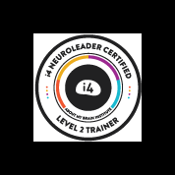

**SURVIVE & THRIVE 2020**

**Online & Distance Delivery Model**

Since 2016 I’ve been diving into research about the connection between neuroscience, neurobiology and neuroplasticity that points to the great capacity of our brains to develop new connections enabling humans to perform and cope optimally in a volatile, ambiguous, complex and uncertain (VUCA) world. And though I thought that the world was volatile, ambiguous, complex and uncertain pre COVID-19, things have ramped up to a level that means we are all living and working in such a world - and we are all looking for ways to deal with it.

The i4Neuroleader Model© can help employees in any role to be more present, have better judgement, deal with pressure, be inspirational to others, be brave, communicate effectively, be optimistic, persevere, better influence others, tolerate complexity, be adaptable and be more intuitive. These are all really valuable traits to have in your tool kit to deal with this VUCA world. When we know how we are performing against specific competencies and elements we can then develop new brain connections to perform optimally and live more satisfying lives.

Based on science and research four competencies have been agreed as being core. To be high performing in these competencies, individuals need to be doing well in the elements shown below:

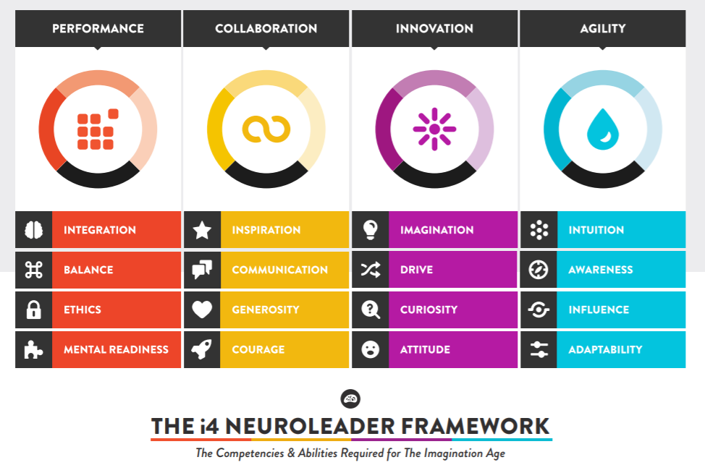

Unlike other models, at Aboutmybrain© ([www.aboutmybrain.com](http://www.aboutmybrain.com)) there is a focus on the whole person – not just the person who shows up at work. The assessment process utilises your friends and family as well as your work colleagues, peers & manager. Through an online survey you can find out how you are doing against these elements, develop a follow up program tailored for you and get unlimited support over the next 6 months. The program suits anyone who want to survive & thrive in this crazy VUCA world – whatever your role. **The** **Survive & Thrive 2020 - Online & Distance Delivery Model includes:**

|  |  |  |
| --- | --- | --- |
| An onboarding meeting using Zoom. Skype or phone (you can buddy up with your workmates if you wish) | Access to the online 360 degree survey (self-assessment & up to 20 raters including colleagues, manager, friends, family) | A Zoom, Skype or phone debrief about your individual report |
| High quality Workbook (posted) | Unlimited phone, Zoom or Skype support to develop & implement your Survive & Thrive Plan over the next 6 months | **The fee for the Survive & Thrive i4Neuroleader Program 2020 is $1550**  **Have questions?**  **Want to register? Email me at** [**gail@everywhensolutions.com.au**](mailto:gail@everywhensolutions.com.au) |
| **Flexible start dates – you choose!** | | |